GENOMORPH: DEVELOPMENT OF AN EDUCATIONAL ACTION-RPG MOBILE GAME AS AN INTERACTIVE CONSERVATION LEARNING TOOL FOR HIGH SCHOOL STUDENTS

KENT DAVE R. PILAR
THOMAS KYLE L. GALO
PSHYCH EARL B. CALEÑADA
RESEARCHERS

ACE B. CARDEÑO
RESEARCH ADVISER

TO BE ANNOUNCED
QUALIFIED SCIENTIST

SCIENCE INNOVATION EXPO

AUGUST 2026
INTRODUCTION
Features and Specifications
GenoMorph is an educational, top-down action-RPG mobile game designed to combine biology, ecology, and environmental conservation with interactive gameplay. Built around real biological adaptations and ecosystem restoration mechanics, the software architecture and gameplay systems consist of the following technical and functional specifications:
- Target Platform: Cross-platform mobile deployment targeting Android (APK) and iOS environments with touch-screen joystick controls.
- Game Engine and Scripting: Developed using the open-source Godot Engine with core game mechanics, entity logic, state management, and user interfaces scripted in C# (.NET).
- 3D Visual Pipeline: Low-poly 3D character models, assets, and biomes created, rigged, and animated using Blender and rendered via an isometric top-down camera perspective.
- Shapeshifting Transformation System: A core DNA switching mechanism enabling players to transform into four native species: Small Native Frog (Anura), Rufous Hornbill (Buceros hydrocorax), Shark (Scoliodon palasorrah patíng), and Dwarf Buffalo / Tamaraw (Bubalus mindorensis).
- Biological Action Skills: Skill sets derived directly from authentic animal adaptations—such as Frog Cutaneous Burst Recovery, Hornbill Casque Impact Dive, Shark Lateral Line Predation System, and Tamaraw Horned Bulwark Charge—replacing fictional or magical powers with scientific principles.
- Ecosystem Restoration Mechanics: Exploration gameplay requiring players to clear invasive nests, remediate areas damaged by pollution and deforestation, and restore ecological balance.
- DNA Knowledge Acquisition and Progression: A system where collecting genetic data and genome fragments unlocks new species forms, provides stat upgrades (Health and Stamina), and advances player strategies through experiential problem-solving.
The game's technical architecture supports accessible cross-platform mobile deployment and scientifically grounded gameplay mechanics. By replacing traditional fantasy elements with authentic biological concepts and experiential problem-solving, GenoMorph serves as an innovative and engaging educational tool for promoting environmental conservation and ecological awareness.

Market Trends and Opportunities
The inspiration for GenoMorph arose from the critical threats of environmental degradation, habitat loss, and biodiversity decline, combined with the challenge of effectively engaging students in biological science education. Despite the urgency of ecological conservation, traditional educational methods frequently struggle to maintain student interest when presenting complex species adaptations and ecosystem interactions, often resulting in limited conceptual retention.

GenoMorph addresses this challenge by merging serious game design with top-down action-RPG mechanics, utilizing the Godot Engine and Blender 3D pipeline for optimized mobile execution. By replacing fictional magic with authentic species traits such as Frog Cutaneous Burst Recovery, Hornbill Casque Impact Dive, Shark Lateral Line Predation System, and Tamaraw Horned Bulwark Charge the system allows learners to experience biological principles directly. Players navigate damaged biomes, clear invasive nests, and collect genetic data to heal ecosystems, transforming abstract concepts into experiential problem-solving
A thorough review of existing educational software confirmed a distinct gap in mobile action games that feature native Philippine wildlife and real-world scientific mechanics. GenoMorph fills this space by offering a specialized, scientifically grounded shapeshifting framework evaluated by educators to ensure pedagogical accuracy. This establishes the system's unique approach to localized biodiversity instruction and environmental education.
While other educational mobile applications exist worldwide, most rely on basic trivia quizzes or fantasy abilities that lack genuine scientific foundation. GenoMorph stands out by delivering a cost-effective, highly engaging, and user-friendly platform designed to build scientific literacy and ecological stewardship, setting a new standard for serious game development in science education.

Statement of the Problem
This study aims to develop and evaluate GenoMorph, an educational action RPG top-down mobile game integrating biological and ecological concepts through interactive gameplay.
Specifically, it seeks to answer the following questions:
- How to design an educational action RPG mobile game integrating native animal adaptations and ecosystem restoration mechanics?
- How to develop the mobile game using Godot Engine and Blender across cross-platform mobile environments?
- What is the performance quality and educational effectiveness of the developed game in terms of:
  - Knowledge Gain?
  - User-Friendliness? and
  - Player Engagement?

Objectives of the Study
This study aims to develop and evaluate GenoMorph, an educational action RPG top-down mobile game integrating biological and ecological concepts through interactive gameplay.
Specifically, it seeks to answer the following questions:
      - To design an educational action RPG mobile game integrating native animal adaptations and ecosystem restoration mechanics;
      - To develop the mobile game using Godot Engine and Blender across cross-platform mobile environments;
      - What is the performance quality and educational effectiveness of the developed game in terms of:
        - Knowledge Gain;
        - User-Friendliness; and
        - Player Engagement;

Engineering Goals
This study is aimed to innovate educational mobile game development by making a top-down action RPG that integrates real-world biological adaptations and ecosystem restoration mechanics.
Specifically, it aimed to:
            - Construct a fully functional mobile application exported as an Android APK that executes with steady frame rates on mobile hardware.
            - Implement responsive touch controls, an intuitive DNA transformation state machine, and stable C# system logic.
            - Establish an optimized 3D asset pipeline between Blender low-poly models (.glb/.gltf/.fbx) and Godot Engine.
            - Ensure integration of authentic biological adaptations into player skill systems, combat mechanics, and educational minigame objectives.

Significance of the Study
This study primarily focuses on the design and development of an educational action-RPG top-down mobile game that enhances traditional methods of teaching biology, ecology, and environmental science. By addressing factors such as student engagement, conceptual retention, and interactive learning, the system offers significant improvements over conventional classroom instruction. It ensures that reliable, scientifically accurate information regarding native species and ecosystem restoration mechanics is available to both learners and teachers.
The significance of this study lies in its potential to empower learners and conservation advocates with an interactive digital platform, enabling players to understand complex ecological dynamics and habitat restoration through experiential problem-solving. By providing problem-based gameplay centered on active ecosystem rehabilitation and biodiversity protection, this system reinforces environmental stewardship, moves beyond passive conservation messaging, and bridges critical gaps in recognizing human impact on delicate natural ecosystems.
Moreover, this study contributes to the knowledge of serious game development and software architecture for environmental applications, particularly in the context of mobile top-down RPGs designed for ecological awareness. It explores the application of open-source development tools, specifically Godot Engine and Blender showcasing how environmental conservation concepts, ecological dynamics,

and native animal adaptations can be integrated into functional, actionable game mechanics.
The innovative approach adopted in this research not only improves community-level environmental education but also serves as a scalable framework that can be adapted and replicated across other localized conservation initiatives and ecosystem restoration models. This can ultimately help foster active ecological stewardship, promote the preservation of endemic wildlife species, and inspire long-term environmental protection and sustainability efforts among future generations.

Definition of Terms
The following terms are defined conceptually within the context of GenoMorph:
ADDIE Model: An instructional design framework consisting of Analyze, Design, Develop, Implement, and Evaluate phases, applied in this study to systematically guide the software engineering lifecycle and educational assessment.
Biological Action Skill: An in-game combat or traversal ability derived directly from authentic animal adaptations—such as Frog Cutaneous Burst Recovery or Shark Lateral Line Sensing—replacing fictional magic with real scientific principles.
Blender: An open-source 3D creation suite utilized for low-poly character modeling, armature rigging, and action animation of native species, environmental props, and invasive entities.
DNA Knowledge Acquisition System: A game progression and reward mechanic where players collect genetic data and genome fragments across damaged biomes to unlock stat upgrades, new animal forms, and educational content.
Godot Engine: An open-source, cross-platform game development engine used to script core entity logic in C# (.NET), manage isometric camera mechanics, and compile mobile Android builds.
Invasive Chimera Boss: An interactive, mutated enemy entity in the game representing environmental pollution, deforestation, and ecological imbalance that players must overcome using specific biological adaptations.
Player Engagement: The degree of immersion, active participation, and interest demonstrated by players during gameplay, measured through standardized usability surveys.
User-Friendliness: The technical usability, touch control responsiveness, and interface clarity experienced by players when navigating menus and controls on mobile hardware.
Knowledge Gain: The quantitative measurement of a player's increase in understanding regarding biological traits, ecosystem services, and conservation concepts.

MATERIALS AND METHODS
This section details the specific materials and methodologies employed in the study to identify, select, and analyze the data necessary for addressing the research problem.
Research Design
This study employed a Developmental Research Design guided by the ADDIE (Analyze, Design, Develop, Implement, Evaluate) model that focuses on the development of GenoMorph, an educational action-RPG top-down mobile game that integrates open-source game engines and authentic biological adaptations to enhance student engagement and environmental science education. The system aims to provide interactive, problem-based learning experiences where players restore damaged biomes and solve ecological challenges using real-world animal traits, allowing for improved conceptual retention and conservation awareness among learners. To ensure the effectiveness of the system, the software prototype was tested based on key evaluation parameters including Knowledge Gain, User-Friendliness, and Player Engagement.
Entry Protocol
The researchers implemented strict administrative and academic protocols to ensure the game functions accurately and efficiently. As part of this process, a formal letter of permission was submitted to the administration of Valencia National High School in Valencia City, Bukidnon to secure approval and assistance for the study. As well as letters of consultation submitted to research adviser.
Location and Duration of the Study
The study will be conducted in the vicinity of Valencia National High School in Valencia City, Bukidnon. This will serve as the primary location for the design, development, testing, and evaluation of GenoMorph, an educational action RPG top-down mobile game. The game will be developed using Blender for creating 3D assets and Godot Engine for implementing gameplay mechanics and educational features related to biology, ecology, and environmental conservation.
Figure 1. Location of the Study



Equipment and Materials Used

- Hardware Equipment
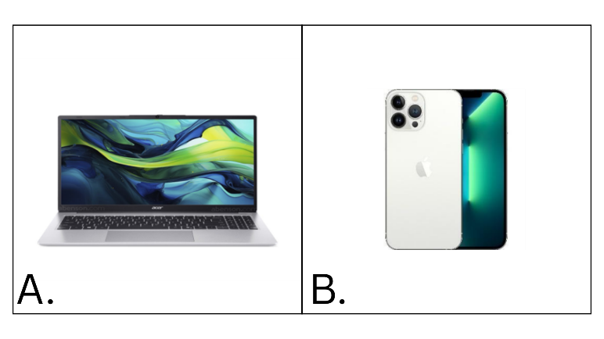
Figure 2. Hardware Equipment

A). Gaming Laptop B). Smartphone

In Figure 2, the laptop and smartphone are the hardware used in the development and testing of the GenoMorph Game App. The laptop is mainly used for developing and managing the game, while the smartphone is used to test its controls, graphics, interface, and overall performance on a mobile device.
A). Gaming Laptop
The gaming laptop serves as the primary hardware for the development of the GenoMorph Game App. It provides good processing and graphics capabilities needed to run development software such as Godot Engine and Blender. It is used to create, edit, organize, and test the game's 3D models, animations, visual effects, scripts, and other components. Its capabilities also support smoother development and allow the researchers to check the game's performance while working on its different features.

B). Smartphone
The smartphone serves as the main testing device for the GenoMorph Game App, since the game is designed for a mobile platform. It is used to evaluate the game's controls, graphics, user interface, responsiveness, and overall performance during actual gameplay. Testing the game on a smartphone allows the researchers to identify issues that may occur on a mobile device and make the necessary adjustments to improve the game's performance, controls, and usability.

- Software Tools
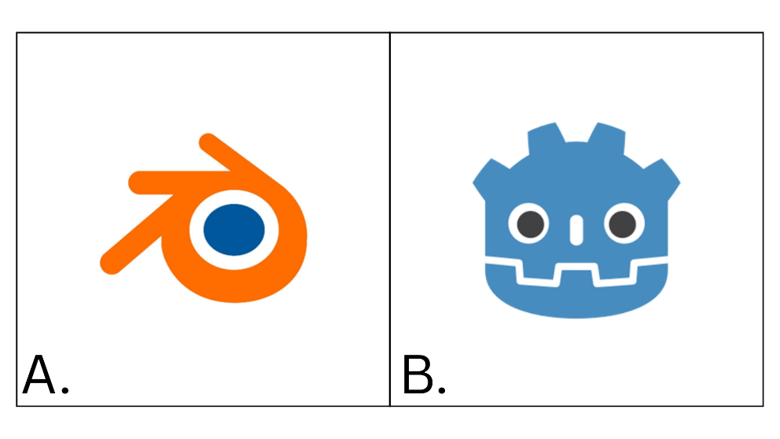
A). Blender Software B). Godot Engine
Figure 3. Software Tools needed for development of the game system

Figure 3 presents the software utilized in the development of the GenoMorph Game App. Godot Engine is used for developing the game mechanics, controls, interface, and other gameplay features, while Blender is used for creating and animating the 3D characters, environments, and visual assets. These software tools support the development and integration of the game components.
A). Godot Engine
Godot Engine is the primary game engine used in the development of the GenoMorph Game App. It is used to develop and integrate the main components of the game, including player controls, game mechanics, quests, user interface, enemy behavior, and other gameplay features. The researchers selected Godot Engine because it provides tools for both 2D and 3D game development and supports the integration of models, animations, audio, and scripts within one development environment. It also allows the researchers to test and adjust the game during development, making it suitable for creating the interactive features and overall gameplay of GenoMorph.
B). Blender Software
Blender is a 3D modeling and animation software used to create the visual assets for the GenoMorph Game App. It is used to develop the 3D models of the game's characters, animals, environments, objects, and other visual elements. Blender is also used for rigging and animation to prepare the characters and objects for movement and interaction within the game. The researchers selected Blender because it provides the necessary tools for creating and modifying 3D assets that can be exported and integrated into Godot Engine.

Risk and Safety Management
During the development of the GenoMorph Game App, the researchers followed proper safety and security practices to protect the game, its users, and the data collected during testing. They used development software, coding tools, and testing devices carefully to avoid problems such as data loss, system errors, crashes, and file damage. Game files and research data were also stored safely and backed up to prevent accidental loss. The researchers followed the Data Privacy Act of 2012 (Republic Act No. 10173) by making sure that any personal information collected during testing was used only for its intended purpose and was not shared without proper permission. Basic cybersecurity measures, such as secure file storage, limited access, strong passwords, and regular backups, were also used to help prevent unauthorized access and protect the information of the participants. These practices helped keep the GenoMorph Game App safe, reliable, and secure during its development and testing.

Procedural Framework

Technological Framework
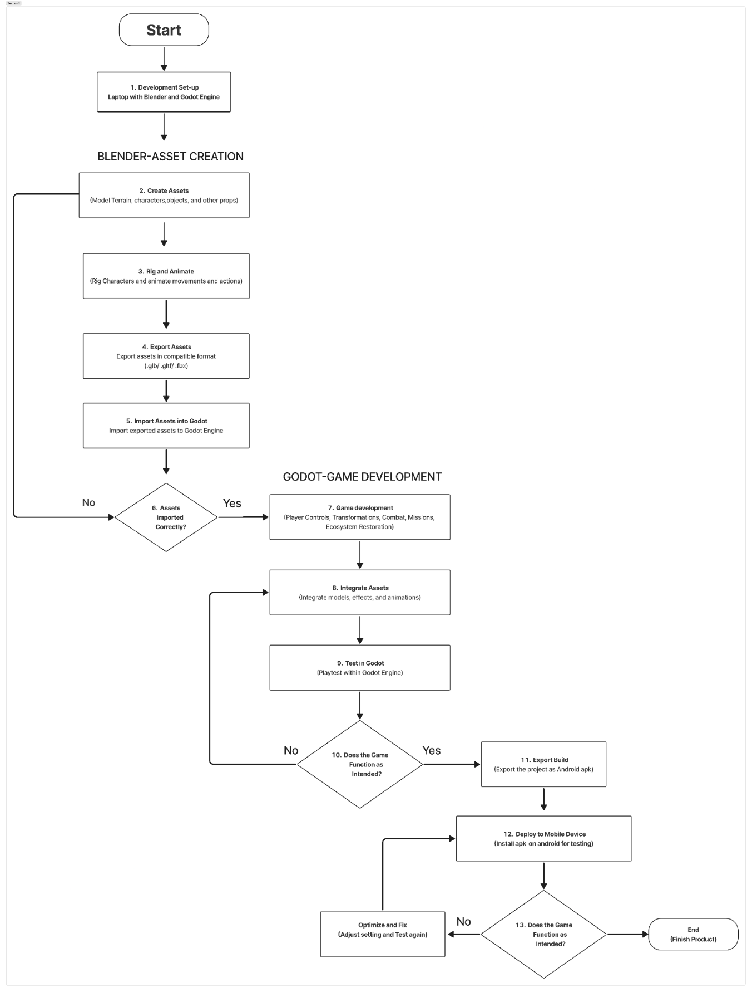
Figure 5. Development workflow flowchart for GenoMorph using Blender and Godot Engine.

Figure 4 above illustrates the development workflow of the GenoMorph game, from project setup to the final mobile application. The flowchart shows how Blender is used to create 3D assets and how Godot Engine is used to develop, test, and deploy the game. It also includes decision points to ensure that errors are fixed before moving to the next stage.
The process starts by setting up Blender and Godot Engine. In Blender, the terrain, characters, and other game assets are created, animated, and exported in compatible formats. These assets are then imported into Godot. If the assets are not imported correctly, they are revised and imported again.
After successful import, the game mechanics, controls, and other features are developed in Godot. The assets are integrated and tested to check if the game works properly. If issues are found, the game is revised and tested again. Once the game functions correctly, it is exported as an Android APK, tested on a mobile device, and optimized if needed until the final version is completed.

Game App Development
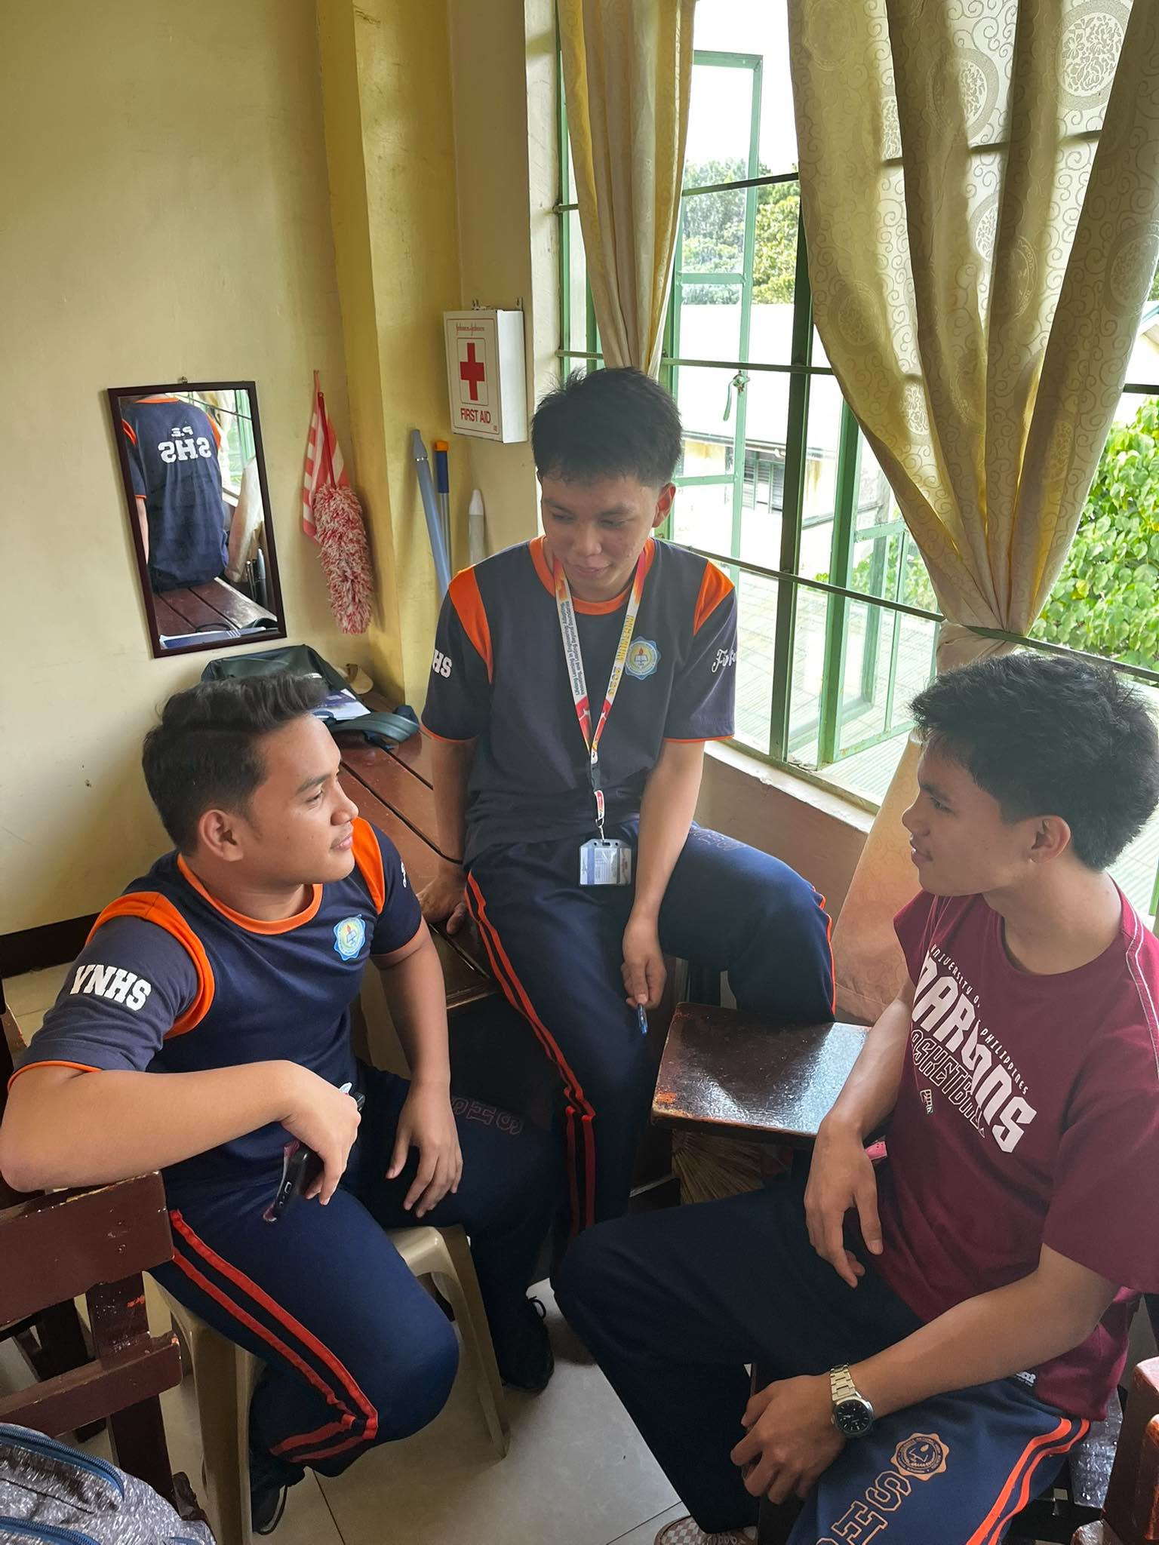
Planning and Concept Development
Figure 6. Planning and exchanging ideas for the game’s concept

The figure shows the researchers during the initial planning and design stage of the game. They identified the game’s objectives, target users, gameplay concept, environmental theme, characters, levels, and required features. They also reviewed different game inspirations, references, and ideas to guide the visual design, gameplay mechanics, and overall direction of the game.

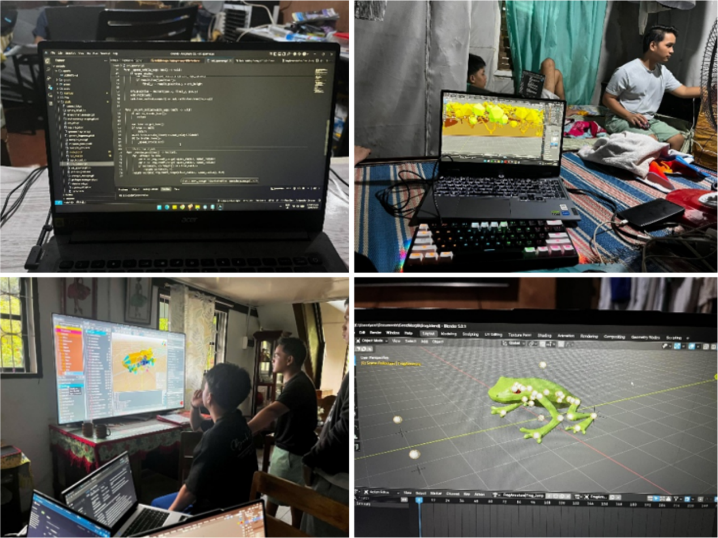
App Design
Figure 7. Designing the mobile game application

The researchers designed the GenoMorph Game App by planning and developing its user interface, game environments, characters, animations, controls, quests, gameplay flow, visual effects, and other interactive features. The design also included the appearance and movement of the characters, the layout of the different environments, the controls used by the player, and the visual elements that support the gameplay. These designs were prepared to make the game clear, functional, and aligned with its educational purpose. Figure X presents the different design elements of GenoMorph, which served as a guide in developing the game's visual, interactive, and gameplay features.
a) User Interface Design
The User Interface (UI) of GenoMorph was designed to provide players with clear information and accessible controls throughout the game. The researchers developed the interface to support navigation, gameplay, environmental exploration, and the presentation of educational content. The UI was designed to match the game's ecological and futuristic theme while keeping important game information easy to identify and understand. The general UI design considerations for GenoMorph include:
- Clarity and Simplicity: Present essential information such as health, stamina, objectives, and controls in a clear and organized manner without unnecessary elements.
- Consistent Design: Maintain consistent icons, layouts, fonts, and visual elements across the game's menus, HUD, and other interface screens.
- Clear Navigation: Provide understandable buttons and controls that allow players to move between the main menu, gameplay, Genome Database, and other game features.
- Player Feedback: Provide visual feedback when players perform actions such as attacking, using abilities, changing forms, or interacting with objects.
- Gameplay Information: Display relevant information such as the player's current form, health, stamina, available abilities, and objectives to support gameplay.
- Educational Integration: Present environmental information through the Genome Database, allowing players to access information about species, ecosystems, and invasive species encountered in the game.
- Thematic Integration: Design the UI to complement GenoMorph's ecological and science-fiction setting, creating a consistent visual connection between the interface and the game environment.
- Readable Text and Icons: Use readable fonts, appropriate text sizes, and recognizable icons so that important information can be understood easily during gameplay.
- Mobile Compatibility: Organize the interface and controls to support mobile gameplay, including accessible on-screen controls for movement, attacks, abilities, and other interactions.
- Testing and Refinement: The researchers tested and refined the UI during development to improve its functionality, organization, and overall usability within the game.
b) System Information Structure
The information architecture of GenoMorph refers to how the researchers organized and structured the game's content and features to make them easy for players to access and understand. The game information was arranged into appropriate sections, including gameplay information, species records, environmental information, characters, technology, and history. The Genome Database serves as a central source for educational content, allowing players to access information about species, invasive species, ecosystems, and environmental events encountered throughout the game. This organized structure helps players locate relevant information while exploring and progressing through the game.

c) Design and Development Technologies
The researchers utilized appropriate design tools and technologies to support the development of GenoMorph. Godot Engine was used as the primary game development platform for integrating gameplay mechanics, user interface elements, environments, and other game features. Blender was used for creating and preparing 3D models, environmental assets, and character assets, including the rigging process for animation. The researchers also gathered free 3D assets from online sources, including the Poly Pizza community, and provided proper credits to the original creators. The combination of these tools provided the researchers with a workflow for developing, organizing, and integrating the game's visual and interactive components.

d) Visual Asset Design
During the development of GenoMorph, low-poly asset and environment design was used to establish the game’s visual style while keeping the overall game optimized. The researchers created and selected low-poly 3D assets for different elements of the game, including characters, plants, rocks, terrain, structures, and other environmental objects. This approach provided the game with a consistent and stylized appearance without adding unnecessary details that could increase the complexity of the 3D environment.
The use of low-poly models was also considered to support the game’s performance, particularly because GenoMorph was designed with mobile devices in mind. By keeping the models relatively simple, the researchers aimed to reduce the amount of graphical processing required while still maintaining recognizable and suitable visuals for each biome. Different environmental elements were designed according to the game’s settings, such as the polluted wetlands, fragmented rainforest, bleached coral reef, and highland mountains, allowing each area to have its own visual identity.
The 3D assets were primarily created and modified using Blender, where the researchers modeled, shaped, and prepared the assets before integrating them into the game. Free 3D models and environmental assets from the Poly Pizza community were also used when appropriate, with the creators properly credited. The completed assets were imported into the Godot game engine, where they were arranged, tested, and refined within the game environment. This process helped the researchers achieve a balance between visual quality, environmental detail, and game performance.
Game Development Process
This section presents the different stages undertaken by the researchers in developing the game, including asset creation, animation, environment development, gameplay features, and the integration of educational content.
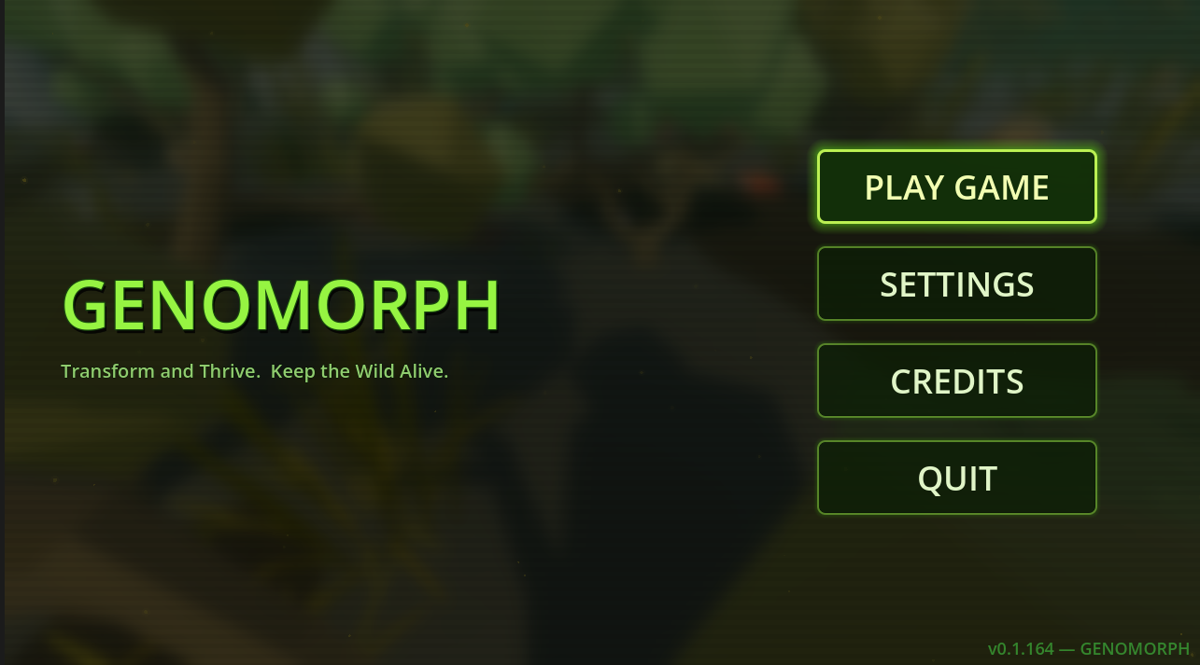
a.)Main menu and user interface
Figure 8. Main game menu

The researchers created the main menu and user interface based on the theme and setting of GenoMorph. The main menu features a blurred view of the game’s biome to give players an initial idea of the game’s environment and ecological theme. The interface was designed to provide a clear and organized starting point for accessing the game and its main features.
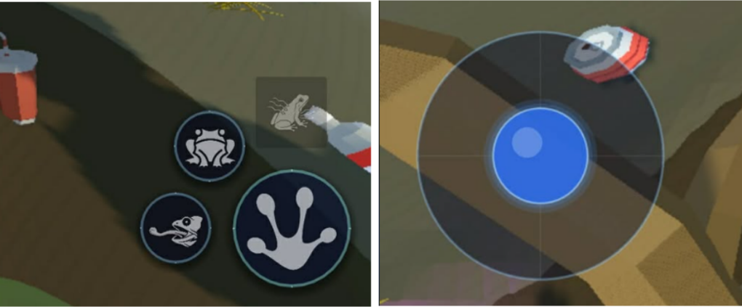
b.) GenoMorph Game Display and Controls
Figure 9. GenoMorph control layout of virtual joystick and skill buttons.

The researchers developed player controls that include the joystick for navigation, basic attack, jumping, tongue attack, and ultimate ability. These controls allow players to move around the environment, perform different attacks, and use character abilities during gameplay. The combat controls were included to allow players to face and respond to invasive species encountered in the game. They also support the completion of quests, missions, and challenges that require movement, combat, and the use of specific abilities.

c.) GenoMorph Game Environment and Biome
Figure 10. Blender 3D of low-poly wetland environment and asset placement.

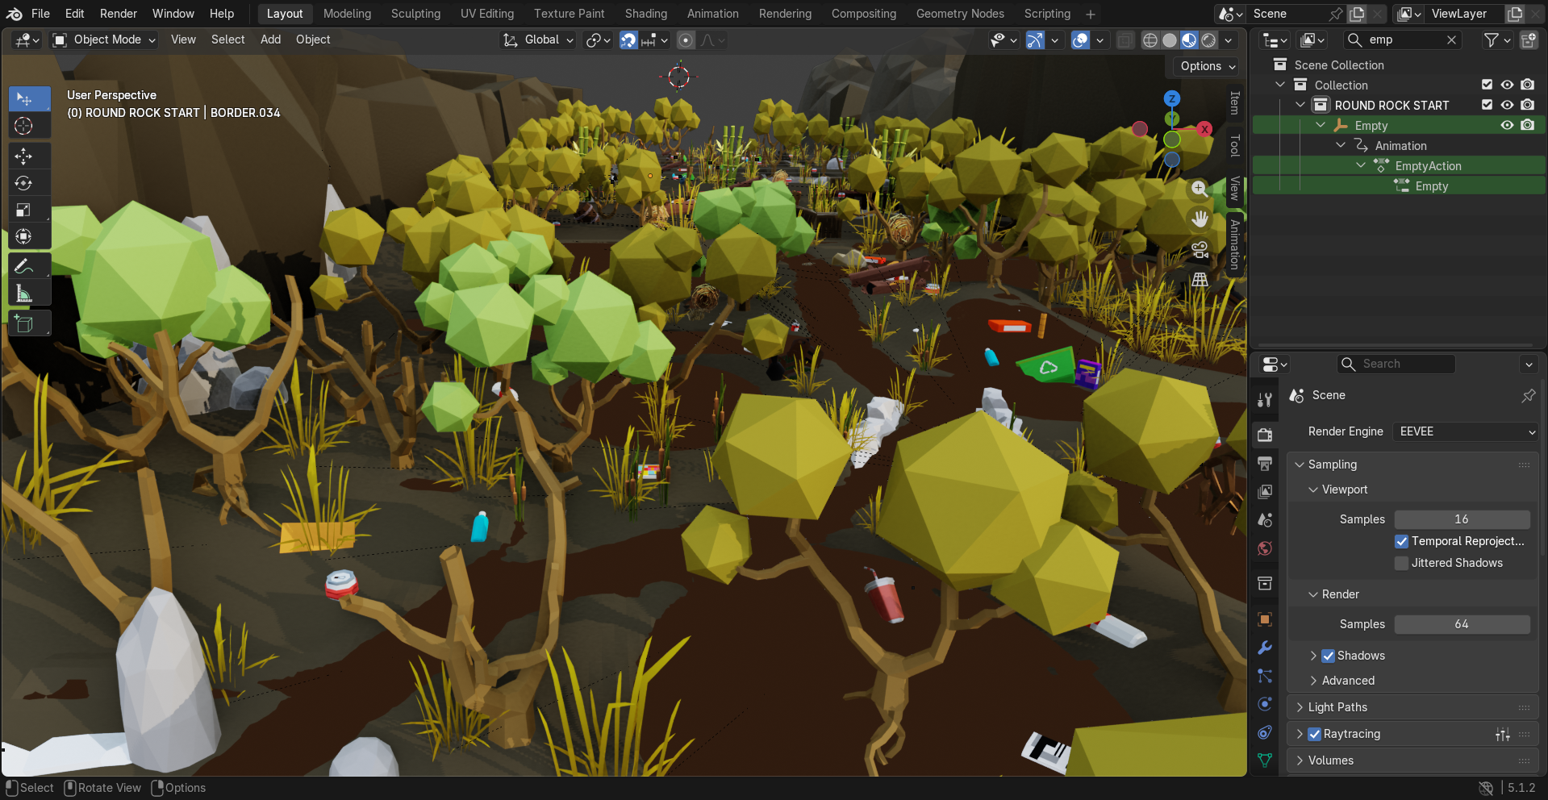

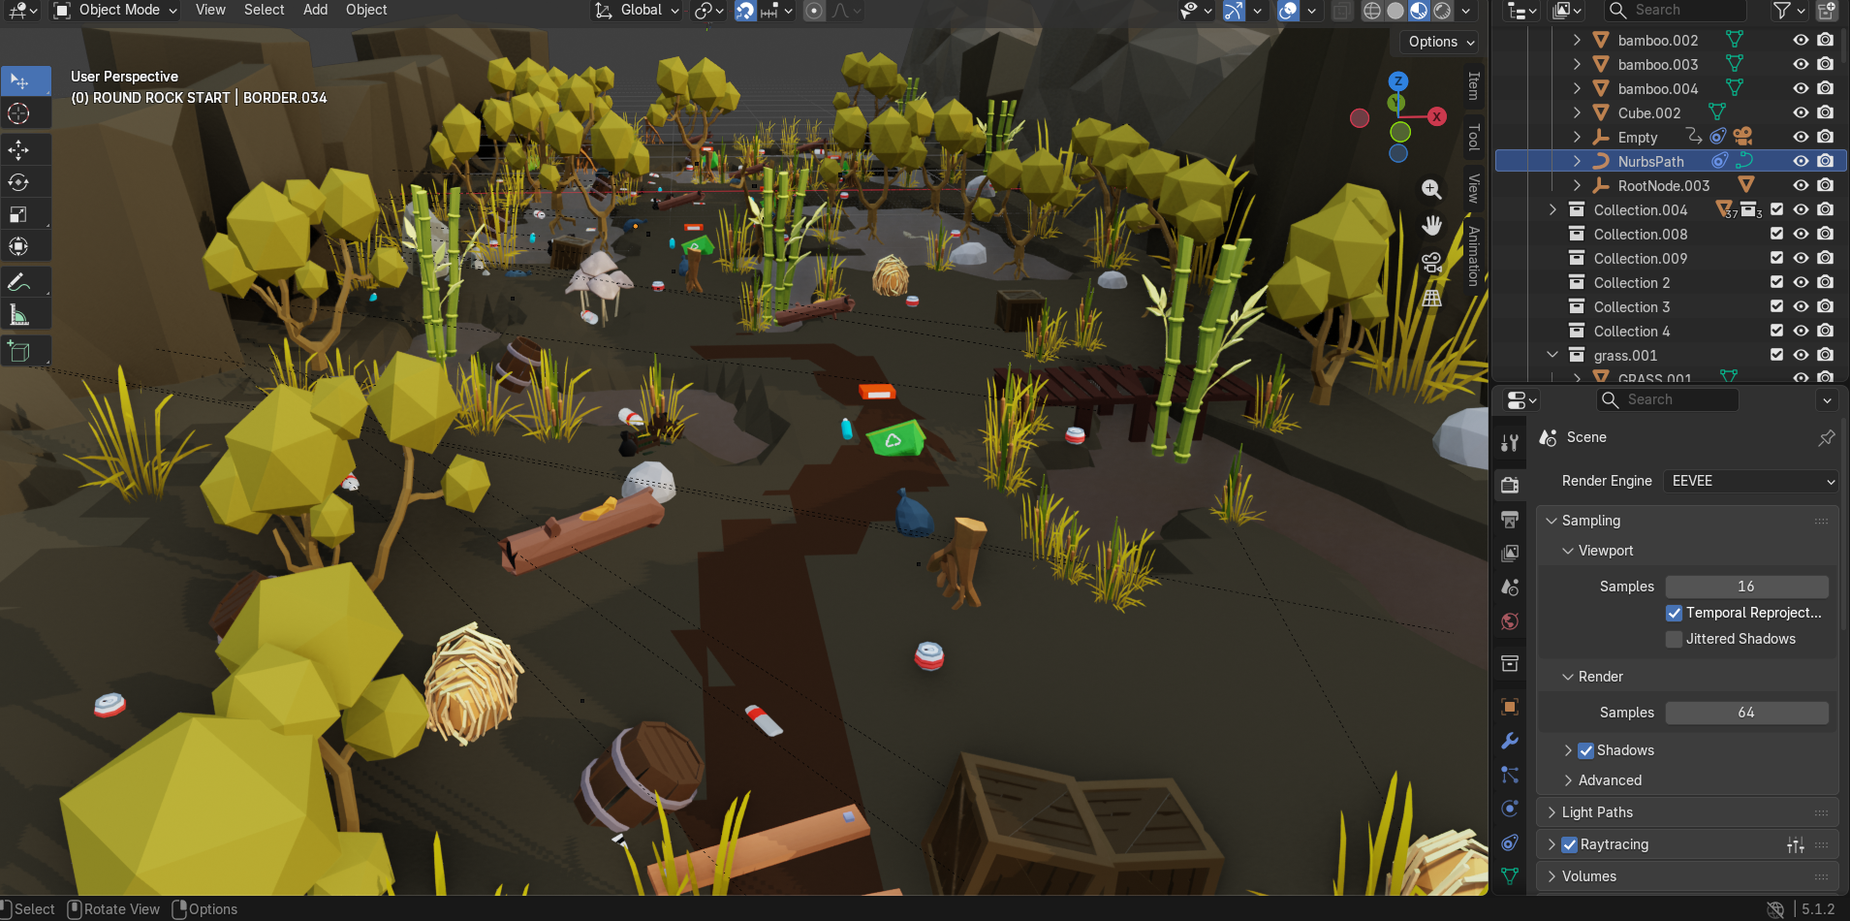

The researchers created the game’s environments or biomes using Blender, where the terrain and environmental elements were manually designed and arranged. They planned which objects would be suitable for each setting, including trees, plants, rocks, trash, and other assets that matched the purpose of the biome. For the wetland environment, the researchers created small holes and lowered areas in the terrain to represent swamp sections. Other environmental assets were then placed around the terrain to make the setting more suitable and consistent with the planned biome. This process allowed the researchers to create game environments that support the game’s theme, level design, and gameplay.
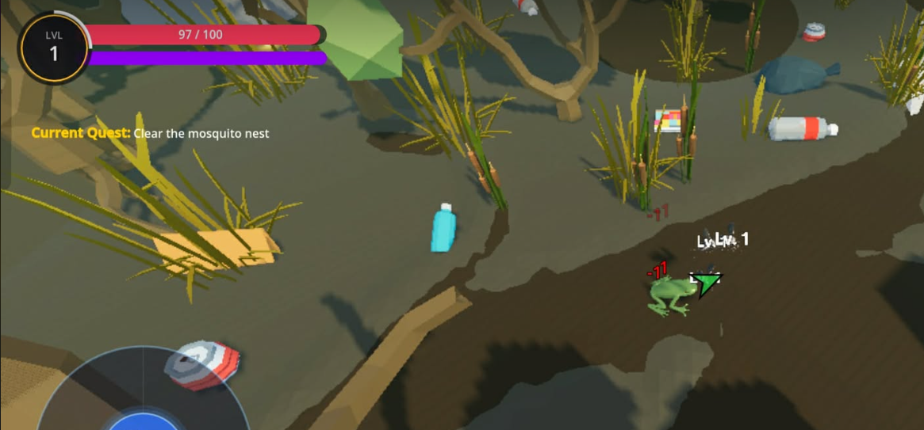
d.) Quests and Objectives
Figure 11. In-game quest interface showing the active objective.

The researchers included quests and objectives to guide players throughout each level and provide a clear direction during gameplay. These features inform players about the tasks they need to complete, such as exploring specific areas, defeating invasive species, collecting resources, or reaching certain locations. By displaying the current quest and its objectives, players can easily understand what they need to do next without becoming confused about the game's progression. The quest system also helps organize the different activities in each level and gives players a clear purpose while exploring the environment. Overall, this feature was developed to make the gameplay easier to follow, support player progression, and help players understand the connection between each task and the main goal of GenoMorph.

e.) Mini-Map, Navigation, and Heads-Up Display (HUD) Elements
Figure 12. GenoMorph interface radar mini-map, navigation, menu, and status indicators.

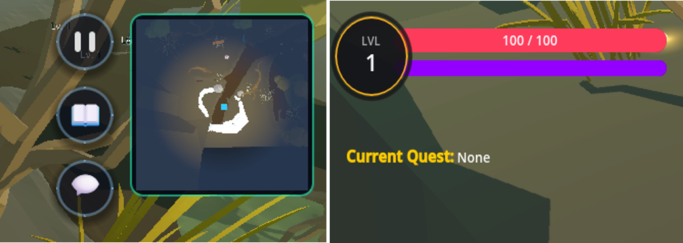

The researchers developed the mini-map and other interface features, including the health bar, stamina bar, and level indicator, to provide players with clear and useful information throughout the gameplay. The mini-map helps players identify their current location and navigate the wetland environment, while the health and stamina bars allow them to monitor their condition and manage their actions during exploration and combat. The level indicator shows the player's current progress and development as they complete objectives and defeat enemies. These interface features were designed to organize important game information in one area, making it easier for players to understand their current status and respond to different situations. Overall, the interface supports smoother navigation, better awareness of the game environment, and a more convenient gameplay experience.

f.) Graphics, 3D Asset Creation, and Asset Sourcing

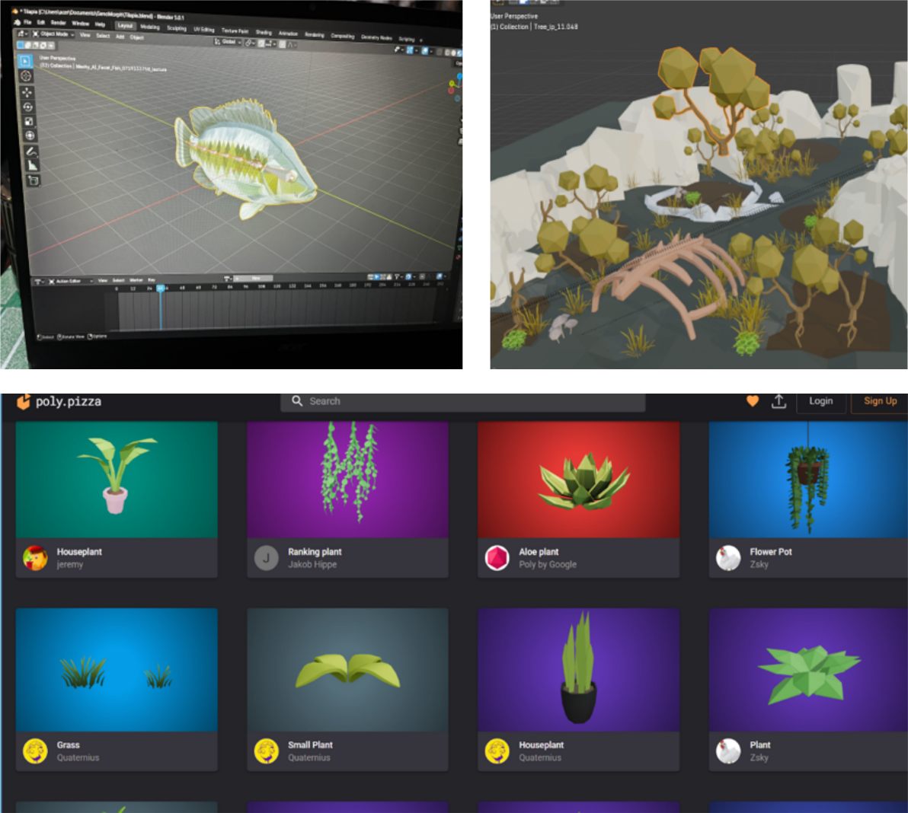
Figure 13. 3D asset creation and sourcing for using Blender and Poly Pizza.

The researchers developed the game’s 3D assets using Blender, modeling selected objects and environmental elements. They also began the rigging process for models intended for animation to allow proper movement during gameplay. To supplement the original assets, the researchers gathered free 3D models and environmental assets from free 3D websites, particularly the Poly Pizza community. The downloaded assets were adapted for the game, and proper credits were given to the original creators.
g.) Educational Environmental Content and In-Game Database
Figure 14. In-game Genome Database educational information of species and ecosystems.
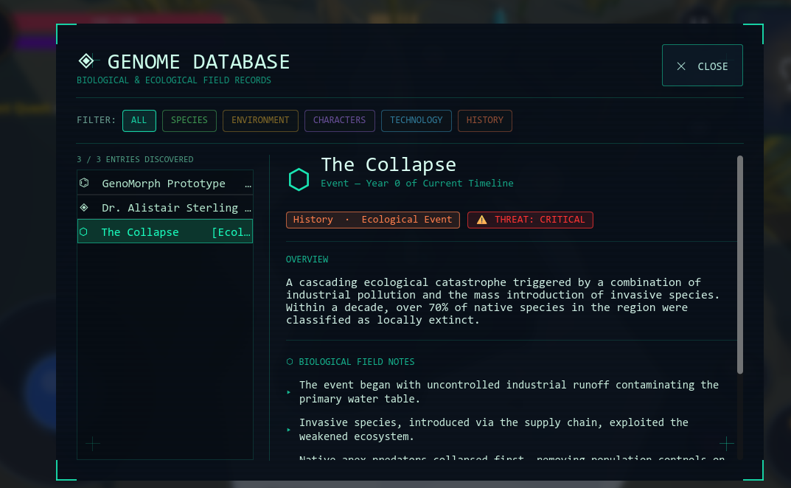

The researchers developed the game by integrating environmental and educational content into the gameplay. They created the Genome Database to provide players with information about the different species, ecosystems, and invasive species encountered throughout the game. The database allows players to learn more about the organisms they encounter and understand their role and effects on the environment. By presenting this information within the game, players can access educational content while continuing to explore and complete different objectives. This feature helps connect the game's educational purpose with its gameplay, making environmental topics easier to understand and more engaging for players.
h.) Core Game Loop and Core Game Puzzle

Figure 15. Core gameplay loop diagrams of tthe RPG combat and puzzle exploration mechanics.
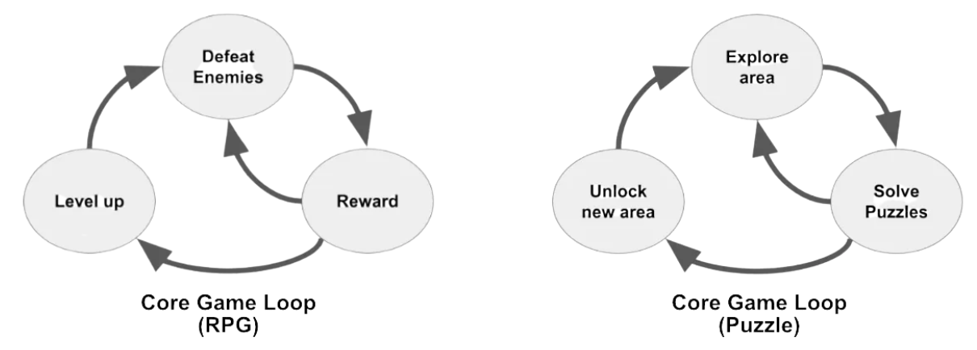

The diagram presents the core game loops of GenoMorph, which show the repeated actions that guide the player's progress. The arrows indicate the order of activities and show what action follows the previous one. In the RPG loop, the player defeats enemies, receives rewards, and levels up, which prepares the player to face enemies again. In the Puzzle loop, the player explores an area, solves puzzles, and unlocks a new area, allowing the player to continue exploring. The arrows return to the starting activities to show that these actions can be repeated throughout the game. Together, the two loops represent the main gameplay cycles of GenoMorph, combining combat and progression with exploration and puzzle-solving.

i.) Integration and Improvement

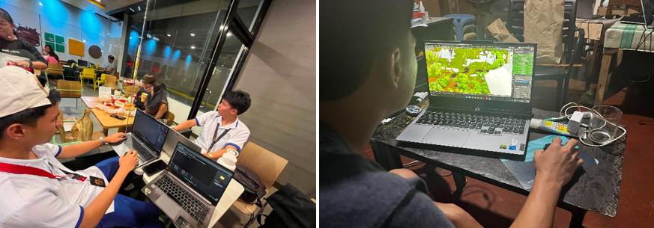
Figure 16. Development team working together on coding, and fixing scene.

The researchers combined the developed game mechanics, controls, user interface, 3D models, animations, environments, quests, visual effects, and other game features into the GenoMorph Game App. Each component was checked to ensure that it worked properly with the other parts of the game. The researchers also identified and corrected errors, adjusted controls, improved visual elements, and made changes to the game's performance based on the results of testing. Figure X presents the integration and improvement stage, showing the developed game components being combined, tested, and refined before the beta testing phase.
Testing Methodologies
Testing was conducted to check the quality, functionality, and performance of the GenoMorph Game App. The researchers used alpha and beta testing to identify issues and improve the game. Alpha testing was conducted by the three (3) game developers to check the game's features, controls, mechanics, and technical problems. Beta testing was then conducted with eight (8) Grade 12 STEM students to evaluate the game's usability, player experience, and satisfaction through the PXI, SUS, and GUESS-18 questionnaires.
- Functional Testing
Functionality testing was conducted to check whether the main features of the GenoMorph Game App worked as intended. The researchers tested the main menu, player controls, transformation system, animal abilities, quests, enemy interactions, settings, mini-map, and other gameplay functions. Any errors or features that did not work properly were identified and corrected during the development process.
- Performance Testing
Performance testing was conducted to check how the GenoMorph Game App performs during gameplay. The researchers evaluated the game's loading, controls, graphics, responsiveness, animations, and overall operation on the gaming laptop and smartphone. This testing helped identify performance issues and determine whether the game could run properly on its intended mobile platform.
- Alpha Testing
The Alpha Testing was conducted by the three (3) game developers who were directly involved in the development of the GenoMorph Game App. This stage focused on checking the game's basic functions, mechanics, controls, user interface, animations, quests, transformations, enemy interactions, and other gameplay features. The developers identified errors, glitches, and performance issues during testing and made the necessary corrections and adjustments. Alpha testing allowed the development team to improve the game before it was provided to external respondents for beta testing.
- Beta Testing
The Beta Testing was conducted with eight (8) Grade 12 STEM students selected through purposive sampling. The respondents were given access to the beta version of the GenoMorph Game App and were asked to play and interact with the game. After testing, they answered the Player Experience Inventory (PXI), System Usability Scale (SUS), and GUESS-18 questionnaires. Their responses were used to evaluate the game's player experience, usability, and satisfaction and to identify areas that could still be improved.

Evaluation of Application
The evaluation of the GenoMorph Game App was conducted to assess its usability, player experience, satisfaction, functionality, and overall performance. The results provided a basis for determining the game's effectiveness and identifying areas for improvement.
- Evaluation Procedure
The evaluation of the GenoMorph Game App focused on determining whether the developed features met the intended purpose of the study. The evaluation considered the gameplay, usability, player experience, controls, interface, graphics, and overall game performance. The results were used to determine how well the application functioned from the players' perspective and to identify specific aspects that could still be improved. The evaluation findings also served as a basis for assessing the overall quality of the developed game.
- Evaluation Criteria
The evaluation criteria focused on the main aspects of the GenoMorph Game App, including player experience, usability, satisfaction, gameplay, controls, interface, and overall performance. The criteria were based on the evaluation instruments used in the study and were used to determine whether the game met its intended functions and provided a satisfactory experience for its users.
- Evaluation of Results
The evaluation results were based on the responses gathered from the completed questionnaires. The data were organized and analyzed according to the criteria of each evaluation instrument. The findings were used to identify the strengths and areas for improvement of the GenoMorph Game App and to determine its overall performance based on the respondents' evaluation.

Data Collection Method
The primary data collection method used in the study was through survey questionnaires administered to eight (8) Grade 12 STEM students who participated in the beta testing of the GenoMorph Game App. The researchers used three adapted evaluation instruments, namely the Player Experience Inventory (PXI), System Usability Scale (SUS), and Game User Experience Satisfaction Scale (GUESS-18) to gather data based on the objectives of the study.
The Player Experience Inventory (PXI) was used to assess the players' experience while interacting with the game. It was included to measure aspects of the gameplay experience and determine how the respondents perceived their interaction with GenoMorph during the beta testing.
The System Usability Scale (SUS) was used to measure the usability of the game, particularly how easy it was for the respondents to understand, navigate, and use its controls and features. This instrument was appropriate because GenoMorph is a mobile game that requires players to interact with different controls, menus, and gameplay functions.
The GUESS-18 was used to evaluate the respondents' satisfaction and overall experience with the game. It helped the researchers determine how the players perceived their experience while playing GenoMorph and their level of satisfaction with the game.
The responses from the three instruments were then compiled and analyzed to assess the player experience, usability, and satisfaction of the GenoMorph Game App. The results provided the researchers with data that could be used to identify the game's strengths and areas that needed improvement during the development process.

Sampling Method
Testing of the GenoMorph Game App. The respondents were selected because they belong to the intended student group for the study and were able to participate in testing and evaluating the game. Their participation allowed the researchers to gather feedback on the game's player experience, usability, and satisfaction using the PXI, SUS, and GUESS-18 questionnaires. Since the participants were selected based on specific criteria rather than randomly, the findings are limited to the selected respondents and may not represent all G rade 12 STEM students.
RESULTS AND DISCUSSION

